Source: https://www.youtube.com/watch?v=Q8PT0jiemKc

John Mearsheimer & Sergey Karaganov: Nuclear Strike on Europe to Restore Deterrence
The main thesis of this video is that NATO is increasingly provoking Russia… by sending to Ukraine weapons, data even allowing to use its territory to fight Russia (air space for drone attacks) which mounts pressure for Kremlin to retaliate -> Ok, so Russia using for example Belarusian territory to do exactly same things… or just simply INVAIDING Ukraine was all Gucci and did not provoked any retaliation? The thesis is fundamentally flawed by being twisted narratively in one direction.

‘The Nuclear weapons are the gift to Russians given by all-mighty’ BROOOOOO
‘it is a task of political scientist and responsible citizens to restore a fear which kept as from fighting against each other’
‘I am surprised to which extend people forgotten red lines that we have, because of the nuclear weapons’ -> then Mearshmeier give example of… UKRAINIAN INVASION!??? On the Kursk region? Brooooo… so just because somebody have nuclear weapons, you cant even fight them when they are trying to slaughter you? Plus, according tu Russian propaganda, territories in zaporozia are parts of Russian state right now, so Ukrainians should remove themselves from them because they are risking something? Russians can just declar whole Ukriane, Baltic States, Poland, theirs territory and everybody needs to agree with them because they have nukes? That is so much… incredible weak statement…

Karaganov – I will criticize my regime for being irresponsible. We should and we must restore deterrence (I would avise that Karaganov would keep his distance away from windows in any near future)
‘This war wasn’t started in 2022, it was started in 1994’ (expansion of NATO) – this is why you CAN’T have any discussion with Russians. They just made up facts… You can’t even say that: how to recognize that Russians are lying? Because they are opening their mouths… because even in silence they are still lying…

If we would use nuclear weapons we would won a war but it would be a terrible moral thing. – at this point I am starting to be convinced that Russians are just terrified that they may use nuclear weapon and NOT win war after that and they will have nothing left.
‘wining war in Europe is very easy’ – yea, it is called 3 days special operation type of easy.
If he so much want to restore the fear from nuclear weapons and ‘rational thinking’ then maybe he sould propose how to do it?

‘Nuclear weapons would be used to coerce others, not the escalation itself but a threat of it would work’ – well, Russians are threating every single day, every single NATO state with nuclear strike, they were threteniing Uk with fake Tsunami weapon… they set a red line on sending helemts to Ukraine… and every single time, when we called bullshit and crossed this fake red line, Russians are like ‘next time we will show you’.. then even when something happened that sould result in nuclear escalation like destruction of strategic radars…. Again nothing happens. So right now, no one is believing Russia in theirs threats.

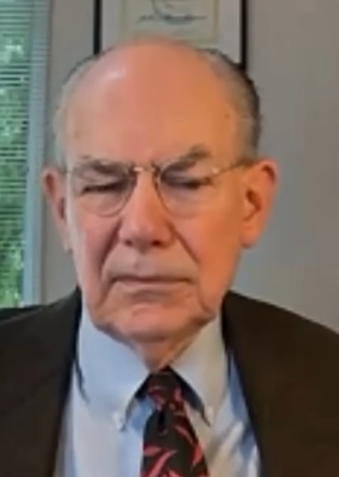
Karganov sounds drunk… Like really, really drunk. (edit: it is just the way he is talking)
Mearsheimer believes that there is no victor in nuclear exchange. Kharganov states that Russia is always a victor in nuclear exchange. The only reason why Russia is not striking is because they would feel bad about it… The look of Mearsheimer face after this drunken speech is priceless.

‘Europeans are good for nothing’ So why are you so afraid of them? You can’t win against Ukraine supported by good for nothing Europeans?

And after all that Karahanov is summing things up that Russia should not use nuclear weapons.. jkust because it is a sin. So how he want to restore deterrence?

Germans (and Japanese)
should be evaporaited from the earth if they even try to get nuclearweapons.
‘If the war (with Europe (nuclear)) begin, the primary targets wont be in Romania or Poland but I Germany.

‘Russians had no issue with Nato existing after cold war.. they had issue with expanding it but not with the existence’ Man… they had no tool to destroy it before collapse, they had no tools to prevent enlargement… they have no saying on that matter.

‘Europe was a source of most disasters in human history; - Excluding everything that everybody else did….

In 20 years from now, Europe will came to its senses but Calvinist Europe, Wester Europe, should be put aside… - there is no realist theoretical background in any mayor thoughts of Karaganov whatsoerver.
When Europe, excluding western, will came to its senses it will join the Asiatic community of states with Russia, China, India, Turkey and others and western Europe will be destroyed
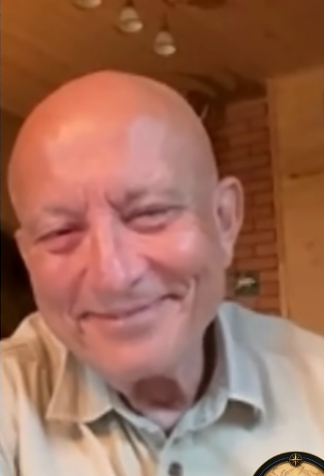
Mearsheimer – I believe that all great powers behave in ruthless way. You criticized Japanesee and japaneese are not European, USA did a terrible things and Russia as well, so I think that you are over focusing on western powers
Karaganov exactly knew that whas he is talking about is a bullshit, just look at his face when Mearschmeier explains to him the last paragraph.

His answear ‘I have some different view on a history’ -> yea that is called Russian bullshit.
Russian conquered but integrated, never eliminaited… (Excluding all the times when they actually eliminatied or removed entire cutlures or performed the small, tiny genocides like Holodomor)… but now I am thinking about future (all you were talking was about past and how ‘west’ should be destroyed for their past.) and the future is… we need to think for better world for the humanity. Europeans belived that this better way is European way but no more… (Did he… fall asleep for the last 70 years? For at least 70 years, Europe is not a leading place for the world…) Spain and Italy will rejoin the ‘normal civilisation’
‘Russia got infected by communism which is one of the worst traits of European civilisation’ - how it is to have such flexible spine to be pro soviet and anti communistic in same moment…???
We (Russians) need to deter USA because they do not act like allies (no shit)

Mearhsmeier – your arguments against Germany, that they drink their aggression with a milk of theirs mothers is same as the argument of eastern Europeans that Russians have aggression in theirs DNA which is just not true. If this argument will get a dominant position in Russia it will complicate matter of trying to reestablish deterrence and will result in a conflict between Russia and Germany.
‘Germany are just a small pawn in this game, they should be put aside’, mhm the 3rd largest economy in the world is a small pawn.. Karahanov propose to treat Europe as irrelevant and that will make them irrelevant… that is not a theory or strategy that is wishfull thinking.

‘I agree with you completely, from one point of view, but’ – Karaganov… all the time.

